NAME: S. DHARANI
REG NO: 192472364
COURSE CODE: DSA0401
NUMPY / PANDAS ANALYSIS – QUESTIONS AND ANSWERS
QUESTION 17: CUSTOMER FEEDBACK WORD FREQUENCY ANALYSIS
AIM:
To preprocess customer feedback, calculate word frequencies, display the top N words and plot a bar graph.
ALGORITHM:
1. Import Pandas, Matplotlib, Counter and string.
2. Load data.csv.
3. Convert feedback to lowercase and remove punctuation.
4. Remove common stop words.
5. Count the remaining words.
6. Get N from the user and display the top N words.
7. Plot the top N word frequencies.
CODE:
import matplotlib.pyplot as plt
from collections import Counter
import re
text = "Good product and good quality Excellent product Good quality product"
words = re.sub(r'[^\w\s]', '', text.lower()).split()
stop = {"the", "and", "is", "a", "of", "to", "in"}
freq = Counter(w for w in words if w not in stop)

top = freq.most_common(int(input("Enter N: ")))
print(top)
plt.bar(*zip(*top))
plt.show()
INPUT:
User input: 3
OUTPUT:
Example top words: product = 2, good = 1, useful = 1
A bar graph of the top 3 words is displayed.
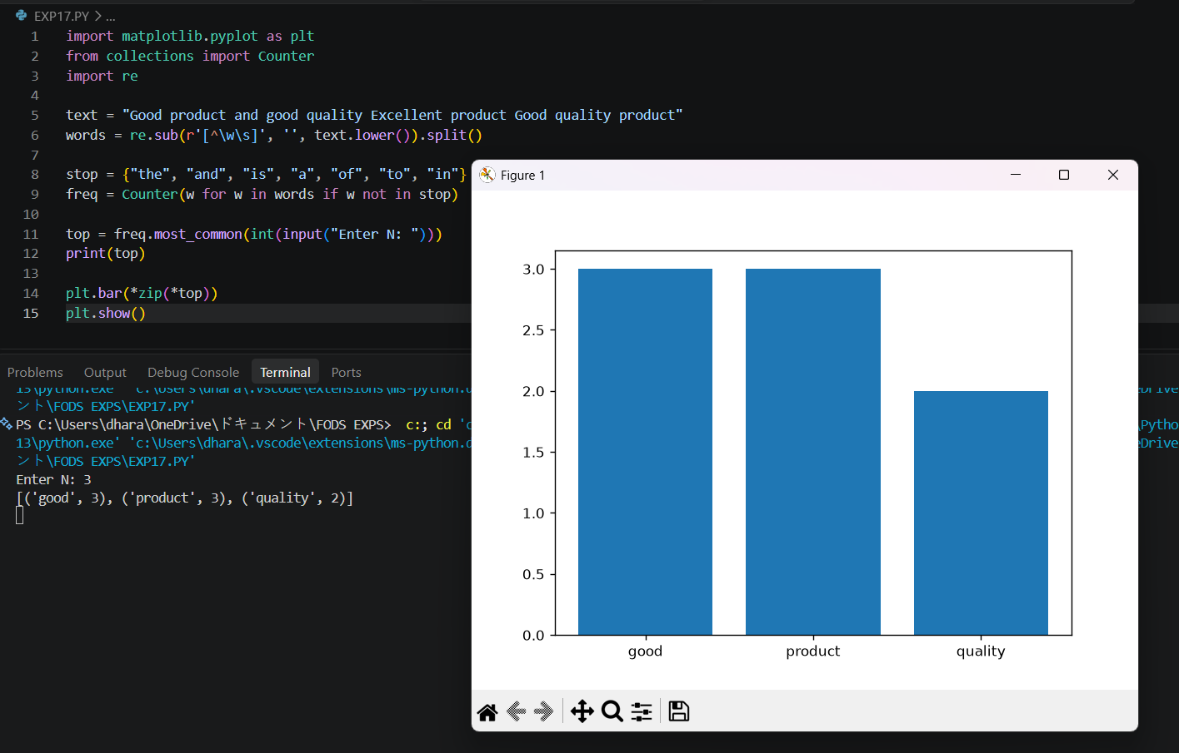
RESULT:
Top word frequencies were calculated and visualized successfully.

